**4.1 Exercise on Functions:**

Task- 1:  
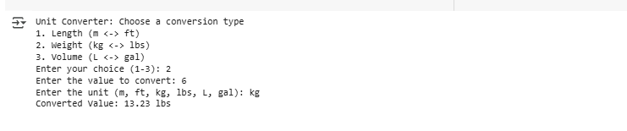

Task- 2:  
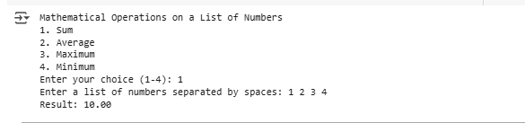

**4.2 Exercise on List Manipulation:**

1. Extract Every Other Element:



2. Slice a Sublist:

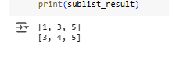

3. Reverse a List Using Slicing:

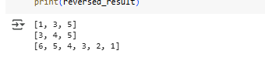  
4. Remove the First and Last Elements:

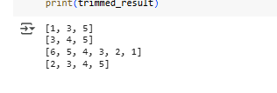  
5. Get the First n Elements:

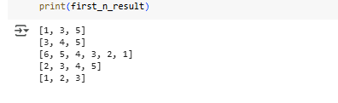

6. Extract Elements from the End:

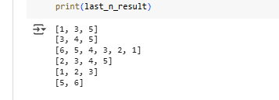

7. Extract Elements in Reverse Order:

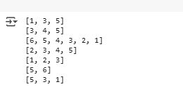

**4.3 Exercise on Nested List:**

1. Flatten a Nested List:

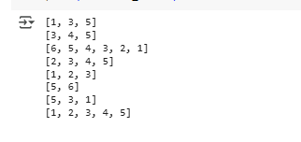

1. Accessing Nested List Elements:

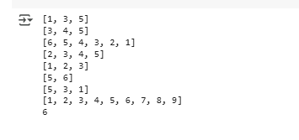

1. Sum of All Elements in a Nested List:

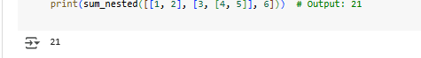

1. Remove Specific Element from a Nested List:

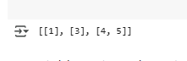

1. Find the Maximum Element in a Nested List

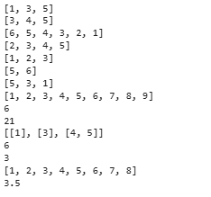

1. Count Occurrences of an Element in a Nested List:



1. Flatten a List of Lists of Lists:



1. Nested List Average:



**10.1 Basic Vector and Matrix Operation with Numpy**

Problem- 1: Array Creation:

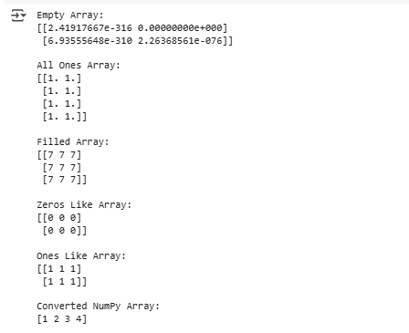

Problem- 2: Array Manipulation: Numerical Ranges and Array indexing:

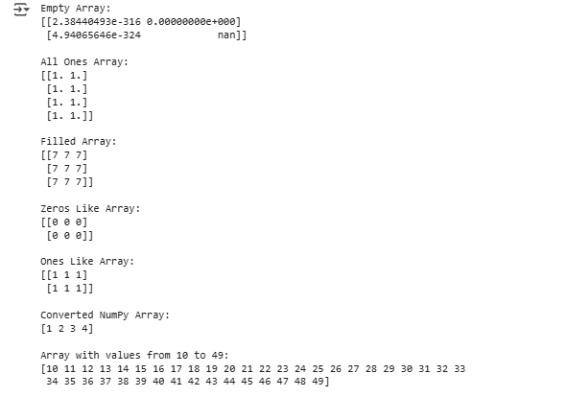

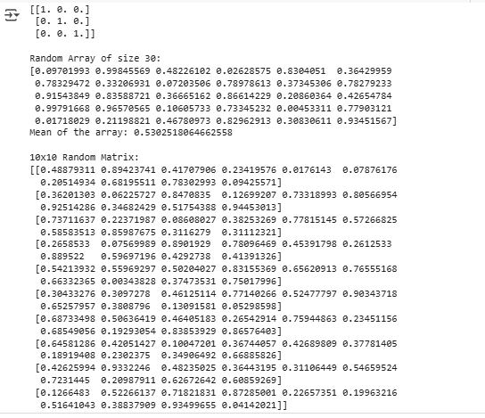

Problem- 3: Array Operations:

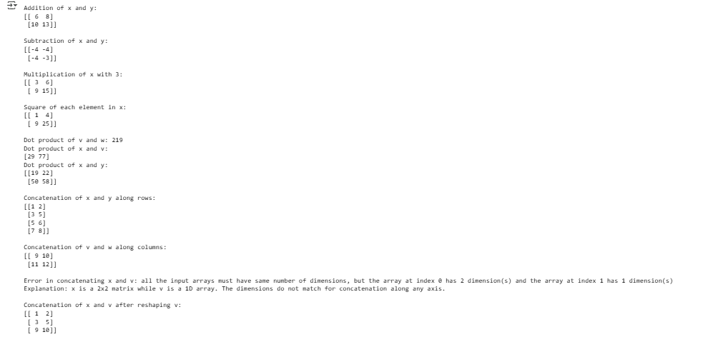

Problem- 4: Matrix Operations:

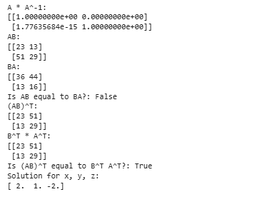

**10.2 Experiment: How Fast is Numpy?**

